**Plan Professional Learning Logic Model & Evaluation Plan**

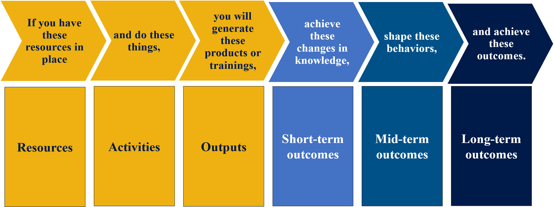

Using the templates below, develop a logic model that identifies a problem of practice with aligned professional learning activities the school, district, or region will implement, as well as the short and long term outcomes. A logic model is a tool that assists with connecting the relationships between different parts of a project or program and the expected outcomes. Logic models provide a framework for program planning, implementation, and evaluation. *Institute of Education Sciences*

Through this process, teams will develop indicators that are evidence based that will be used to monitor progress towards the intended outcomes. Add additional rows if needed. Each plan should connect the relationships between adult professional learning that lead to improved student outcomes.

In order to continuously improve the effectiveness of the professional learning provided, Design Teams will need to develop an evaluation plan. Use the template below to identify evaluation questions, data/evidence, data sources, method of data collection and a timeline for each question. Add additional rows if needed.

Resources for support:

* Contact your local [Regional Educator Network Staff](https://eac.ode.state.or.us/page/regional-educator-networks) for technical assistance
* Regional Educational Laboratory [Logic Model and Evaluation Toolkit](https://ies.ed.gov/ncee/rel/Products/Region/central/Resource/100644/2)
* Regional Educational Laboratory [Definitions of Logic Model Components](https://ies.ed.gov/ncee/rel/regions/central/pdf/CE5.3.2-Definitions-of-Logic-Model-Components.pdf)

**Logic Model**

|  |  |  |  |  |  |  |
| --- | --- | --- | --- | --- | --- | --- |
| **Problem of Practice Statement** *A problem of practice is a dilemma that cannot be easily resolved, but is grounded in evidence derived from multiple perspectives. It should be actionable and connect to a broader strategy of improvement. It should be within the team's locus of control* | | | | | | |
|  | | | | | | |
| **Resources** *What is the team able to invest to accomplish the desired outcomes?* | | | | | | |
|  | | | | | | |
| **Professional Learning Standards** | **Activities** | **Outputs** | **Outcomes** | | | |
| *What* [*Learning Forward*](https://standards.learningforward.org/wp-content/uploads/sites/29/2022/04/Standards-Summary.pdf) *standards will the plan align to?* | *What evidence-based activities will be implemented? Include as many activities as needed* | *What will be produced as a result of the activities?* | **Short term:** What *knowledge and skills will be gained?*  *(2025-26)* | **Mid term:** What *changes in practices and behaviors will we see as a result of knowledge/skills gained? (2026-27)* | **Intended Educator Results:** *What increase/change in Educator skill, knowledge, behavior as a result of the professional learning?* | **Intended Student Results:** *What increase/change in student skill, knowledge, behavior as a result of educator professional learning?* |
|  |  |  |  |  |  |  |
| **Indicators: Evidence of Implementation and Success** *What goals are you trying to achieve and how would you know if you achieved them? What indicators would provide evidence that the resources are in place? What data would be required for the indicators? Identify indicators for each column of the logic model.* | | | | | | |
|  |  |  |  |  |  |  |

## **Evaluation Plan**

|  |  |  |  |  |  |
| --- | --- | --- | --- | --- | --- |
| **Evaluation Question(s)** | **Person Responsible** | **Data/Evidence needed** | **Data Source** | **Data Collection Method** | **Timeline** |
| *Example: How frequently are teachers integrating THSH lessons into their math curriculum?* | *Teacher* | *Teacher Lesson Plans* | *Lesson Plans* | *Review Lesson Plans for Math Dept.* | *Quarterly Lesson Plan reviews* |
| *Principal* | *Teacher behavior* | *Principal observations* | *Observation notes/logs* | *Bi-monthly observations Oct-May* |
|  |  |  |  |  |  |
|  |  |  |  |  |  |